**Project Design Phase-II Data Flow**

**Diagram & User Stories**

|  |  |
| --- | --- |
| Date | 11 November 2022 |
| Team ID | PNT2022TMID18766 |
| Project Name | Project – Real Time Communication System Powered by AI for Specially Abled. |
| Maximum Marks | 4 Marks |

**Data Flow Diagrams:**

A Data Flow Diagram (DFD) is a traditional visual representation of the information flows within a system. A neat and clear DFD can depict the right amount of the system requirement graphically. It shows how data enters and leaves the system, what changes the information, **Data Flow Diagram:**

**:**

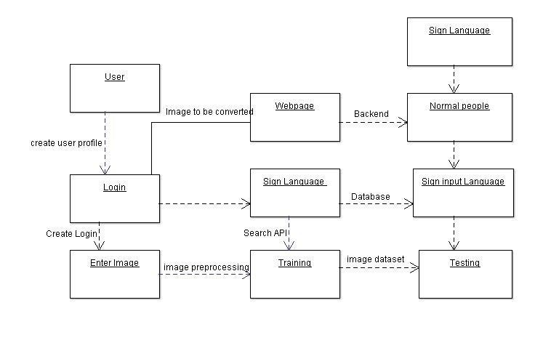

**User Stories:**

|  |  |  |  |  |  |  |
| --- | --- | --- | --- | --- | --- | --- |
| **User Type** | **Functional**  **Requirement (Epic)** | **User Story**  **Number** | **User Story / Task** | **Acceptance criteria** | **Priority** | **Release** |
| Customer (Low vision) | Registration | USN-1 | As a user, who has trouble reading due to low vision, I want to be able to make the text larger on the screen so that I can read it. | I can access my account / dashboard | High | Sprint-1 |
| Customer  (Color blindness) |  | USN-2 | As a user, who is color blind ,I want to have access to information conveyed in color so that, I do not miss anything and I understand the content. | I can receive confirmation email & click confirm | High | Sprint-1 |
| Customer  (Impaired user) |  | USN-3 | As a user, who is hearing-mpaired, Iwant a transcript of the spoken audio so that I can have access to all information provided in audio clips | I can register & access the dashboard with Facebook Login | Low | Sprint-2 |